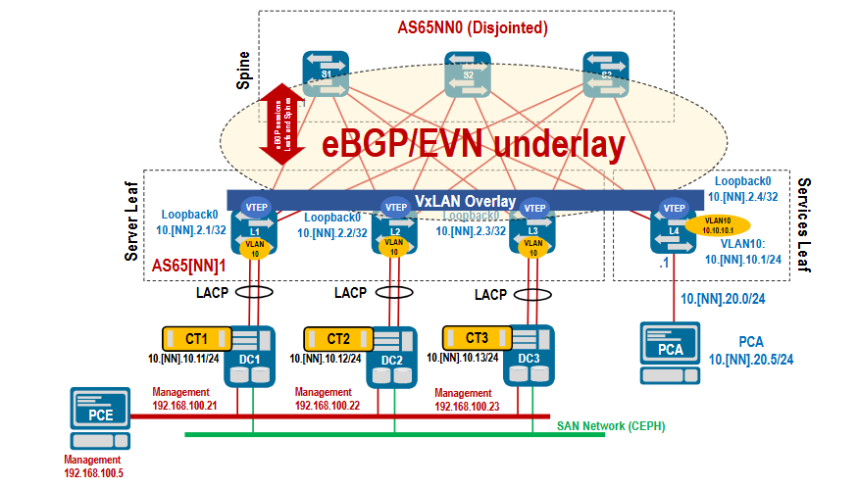

3220

SPINE:

router bgp 65460
router-id 10.46.1.3
bgp listen range 10.46.0.0/16 peer-group LEAF remote-as 65461
neighbor LEAF peer group
network 10.46.1.3/32

LEAF 1:
router bgp 65461
router-id 10.46.1.1
neighbor SPINE peer group
neighbor SPINE remote-as 65460
neighbor 10.46.11.1 peer group SPINE
neighbor 10.46.21.1 peer group SPINE
neighbor 10.46.31.1 peer group SPINE
network 10.46.1.1/32

lEAf 2:

router bgp 65461
router-id 10.46.2.4
maximum-paths 8 ecmp 8
neighbor SPINE peer group
neighbor SPINE remote-as 65460
neighbor SPINE allowas-in 1
neighbor 10.46.14.1 peer group SPINE
neighbor 10.46.24.1 peer group SPINE
neighbor 10.46.34.1 peer group SPINE
network 10.46.2.4/32

neighbour SPINE allowas-in

Step2

router bgp 65460
neighbor LEAF send-community extended
!
address-family evpn
neighbor LEAF activate
!

router bgp 65461
neighbor SPINE send-community extended
!
address-family evpn
neighbor SPINE activate
!

interface Vxlan1
vxlan source-interface Loopback0
vxlan vlan 10 vni 1010
!
router bgp 65461

1:10.10.10.0/24

2:10.10.10.0/24

1:00:02:ab:ba:cd:00

2:00:02:ab:ba:cd:00

interface Vxlan1
vxlan source-interface Loopback0
vxlan vlan 10 vni 1010

!
router bgp 65461
vlan 10
rd 10.46.2.4:1010
route-target both 65460:1010
redistribute learned
!
!

